Black-Box Techniques

What is Black-Box Techniques
# Source: AI Source: Provided by: [Data Path: Persons Table -> ID Column: 1, Name_En Column: Motasem Essam] -> From: [Chatgpt (GPT‑5 Mini)] on [8/24/2025]
Black-Box Techniques are test design methods where you test the functionality of a system without looking at the internal code or structure.
You focus only on:
- What the system should do (based on requirements/specifications)
- Inputs → Outputs (cause → effect)
It’s called black box because the “inside” (code logic) is invisible to the tester — you just know what goes in and what should come out.

Key Points
# Source: AI Source: Provided by: [Data Path: Persons Table -> ID Column: 1, Name_En Column: Motasem Essam] -> From: [Chatgpt (GPT‑5 Mini)] on [8/24/2025]
- Based on requirements, specifications, and user expectations.
- Used at all test levels (unit, integration, system, acceptance).
- Best for functional testing.
- Tester does not need programming knowledge.

Main Black-Box Techniques
# Source: AI Source: Provided by: [Data Path: Persons Table -> ID Column: 1, Name_En Column: Motasem Essam] -> From: [Chatgpt (GPT‑5 Mini)] on [8/24/2025]
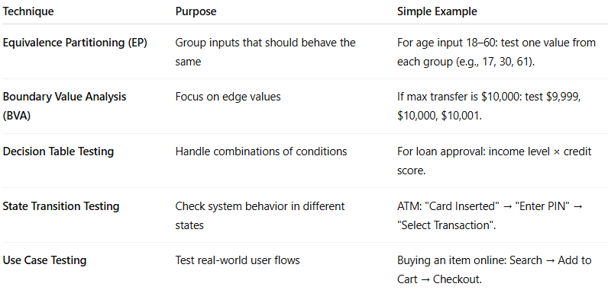
Technique | Purpose | Simple Example
Equivalence Partitioning (EP) | Group inputs that should behave the same | For age input 18–60: test one value from each group (e.g., 17, 30, 61).
Boundary Value Analysis (BVA) | Focus on edge values | If max transfer is $10,000: test $9,999, $10,000, $10,001.
Decision Table Testing | Handle combinations of conditions | For loan approval: income level × credit score.
State Transition Testing | Check system behavior in different states | ATM: "Card Inserted" → "Enter PIN" → "Select Transaction".
Use Case Testing | Test real-world user flows | Buying an item online: Search → Add to Cart → Checkout.

Real-World Example
# Source: AI Source: Provided by: [Data Path: Persons Table -> ID Column: 1, Name_En Column: Motasem Essam] -> From: [Chatgpt (GPT‑5 Mini)] on [8/24/2025]
Feature: Online Shopping Checkout
- Requirement: “The system shall allow checkout with Visa, MasterCard, or PayPal.”
- EP: Test one valid Visa card, one MasterCard, one PayPal account, and one invalid payment method.
- BVA: Test cart totals at $0, $1, and just above $500 limit.
- Decision Table: Combine “payment method” × “shipping method” to ensure all combinations work.

